
Chainsaw Tips
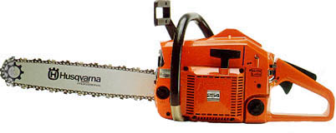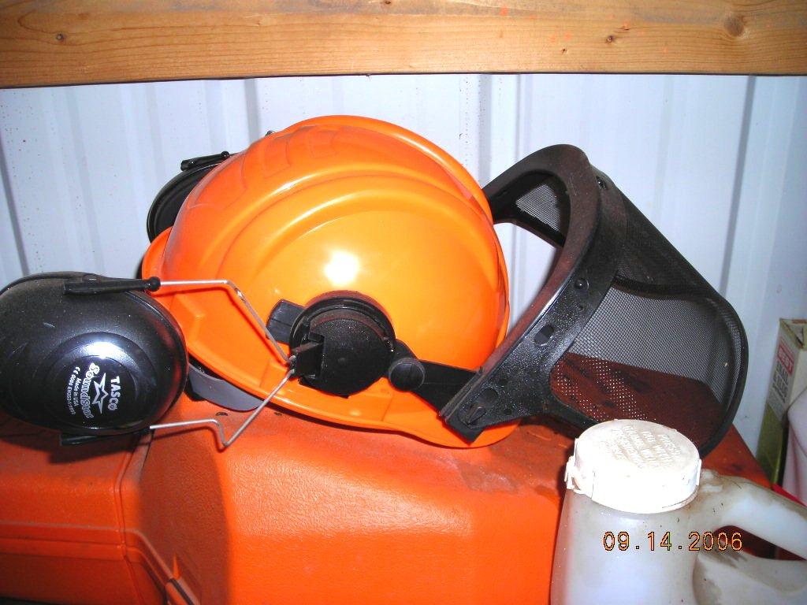
Proper instruction & information is critical
Do not to use any chainsaws without proper instruction; you are risking your safety as well as the safety of others by doing so. You must be properly trained to operate this equipment safely. Proper training must include a review of the operator’s manual as well as a skills evaluation to assure that you understand the features of this piece of equipment and can use it safely.

Hazards
Many hazards are involved when using a chainsaw including the following:
- Exposure to mechanical hazards from the chain and other moving parts
- Kick-backs of the bar
- Being struck by falling objects
- Flying particles of dirt or debris, or other particles discharged from the bar
- Slopes, uneven, or unstable ground that could potentially result in slips/trips/fall
- Foreign objects in the eyes
- Repetitive motion injuries
- Exposure to outdoor environments including insects, sun, and allergens
- Noise and vibration exposure
- Exposure to exhaust gases such as carbon monoxide in poorly ventilated areas
- Exposure to gas, oil, and other fluids
- Burns from the exhaust system
Before use
Inspect and test the equipment to manufacturer requirements before each use to assure that the safety devices are working. All guards should be in place and the equipment should be in good, ready-to-use condition. Follow the manufacturer’s recommendations for proper scheduled maintenance. Complete a written field inspection form to document that the equipment is working properly and suitable for use. Do not use the equipment if unsafe conditions exist.

Personal Protective Equipment (PPE)… Required PPE (Must be worn)
- Body: Coveralls or Shirt/Pants (Long Sleeve/Long Legged, Tight Fitting)
- Legs: Chainsaw protective chaps or chainsaw protective pants (ANSI Spec.; UL Listed)
- Feet: Steel Toed Leather Boots, Antislip, Ankle Height
- Head: Hard Hat and Mesh Face Shield, Goggles/safety glasses must be worn underneath
- Ears: Ear Plugs or Muffs when operating or around noisy equipment
- Hands: Heavy Work Glove (Leather or Similar/anti-vibration)
- Eyes: Goggles/Safety Glasses (with side shields or wrap around lenses; can be shaded)


Chainsaw Tips

Maintenance and Repairs
- Don’t work on running or hot equipment—shut it off and let it cool
- Disconnect the spark plug wire or electric cord before performing mechanical adjustments, maintenance, repairs, or removing obstructions from around the chain/bar
- Use proper methods to secure and sharpen the chain
- If you’re not qualified to make appropriate repairs using safe work practices, contact an authorized and qualified equipment mechanic

Operating the Equipment
- Establish good, stable footing
- Make a plan for the work to be done and identify and establish controls for the hazards present
- Choose the correct sized saw for the job
- Assure that the saw is sharp, chain properly tensioned, and ready to operate before starting
- Use both hands to start the saw, one to hold the saw (some saws also allow you to use a foot) and the other to pull the cord. (Drop (Mid-Air) Starts are not allowed)
- Make sure the safety features of the saw are in place and working, including a reduced kickback bar, low kickback chain and chain brake
- Make sure rocks and other obstacles have been removed from cutting area
- Avoid contact between the bar tip and any object, or the dirt as it can result in a kick back and/or damage or dull the chain
- Hold the chainsaw firmly with both hands
- Don’t overextend when cutting
- Don’t cut above shoulder level
- Check the chain brake frequently
- Never cut when tired or alone
- Follow sharpening and maintenance instructions for the chainsaw
- Plan and clear an escape route when falling a tree, as the tree falls, stop motor, set the saw down and move quickly from the base of the tree rapidly at a 45 degree angle from the path of the fall
- Avoid making cuts with the saw between your legs, always cut with the saw to the outside of your legs
- Don't stand on a log and saw between your feet
- Stand to the side of the limb you are cutting, don’t straddle it
- Keep yourself and other people out of the cutting path in the event that the chain breaks
- Do not fuel hot or running equipment. Use a rag to wipe up fuel spills
- Equipment operators shall be trained and qualified to operate all chainsaws that they may be asked to use. Manufacturer's instructions and operating procedures shall be followed. Training must be documented and kept on file
- Before working in an area, the equipment operator must make sure the area is clear of people and other hazards
- Transport the chainsaw in an upright position to prevent fuel spillage. Keep out of the passenger area of the vehicle. Keep in a case or cover the bar with a chain guard

Chainsaw Tips
This form documents that the training specified above was presented to the listed participants. By signing below, each participant acknowledges receiving this training.

Organization:

Trainer: Trainer’s Signature:

Class Participants:

Name: Signature: Date:

Name: Signature: Date:

Name: Signature: Date:

Name: Signature: Date:

Name: Signature: Date:

Name: Signature: Date:

Name: Signature: Date:

Name: Signature: Date:

Name: Signature: Date:

Name: Signature: Date:

Name: Signature: Date:

Name: Signature: Date:

Name: Signature: Date:

Name: Signature: Date:

Name: Signature: Date:

Name: Signature: Date:

Name: Signature: Date:

Name: Signature: Date:

Name: Signature: Date:

